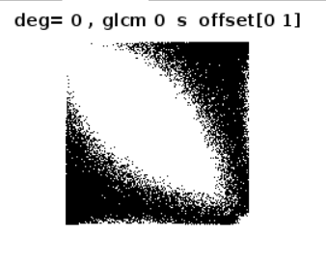

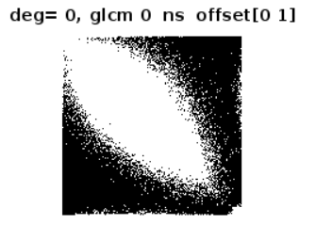

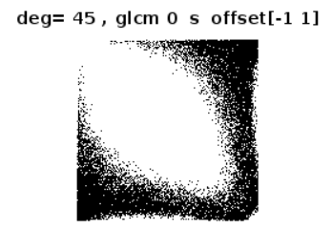

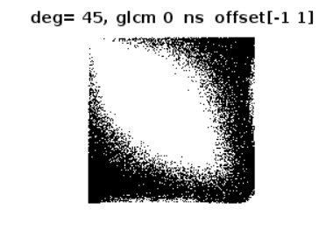

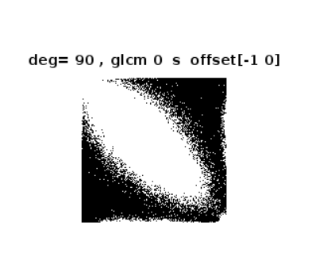

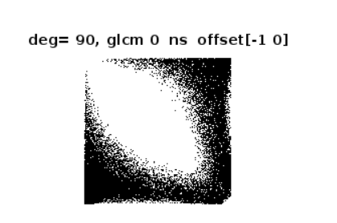

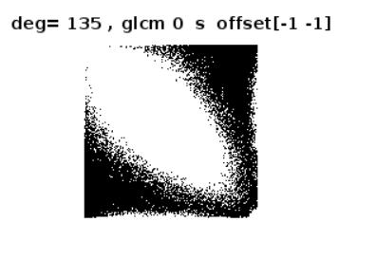

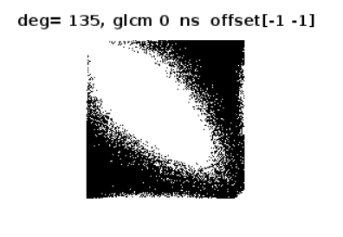

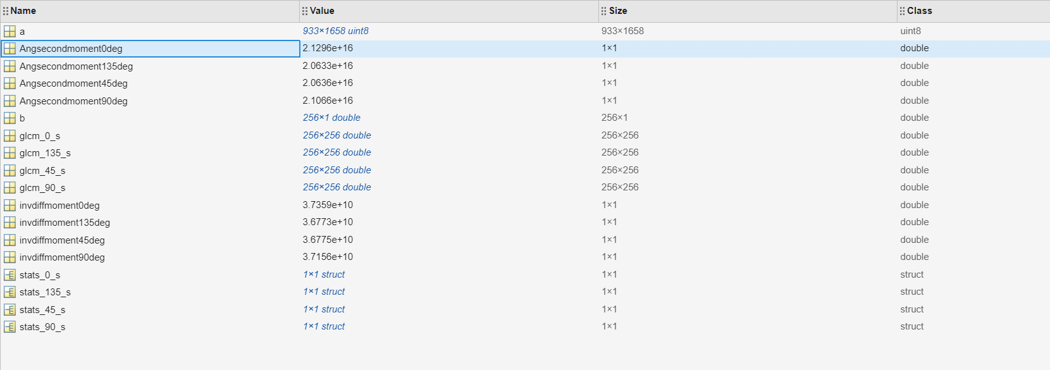

|  |  |  |  |  |  |  |  |
| --- | --- | --- | --- | --- | --- | --- | --- |
| degree | Features-🡪 | Contrast | Correlation | Energy | Homogeneity | Angular second momentum | Inverse difference moment |
|  |  |  |  |  |  |  |  |
| 0 |  | 3.130697492401275e+02 | 0.970592915051038 | 0.034121827809747 | 0.358676158739511 | 2.129623268091494e+16 | 3.735866572800000e+10 |
| 45 |  | 4.966956869154408e+02 | 0.953226243664635 | 0.033115989689757 | 0.327958352687045 | 2.063643953751654e+16 | 3.677539532800000e+10 |
| 90 |  | 2.531537195131415e+02 | 0.976194579319536 | 0.033799767684741 | 0.362560691415947 | 2.106627912132198e+16 | 3.715642163200000e+10 |
| 135 |  | 4.065867382751287e+02 | 0.961711789479443 | 0.033115687456148 | 0.331334815184579 | 2.063320342960538e+16 | 3.677251174400000e+10 |